POWER SUPPLY MOUNTING & WIRING METHODS
AC power input in the USA (120 volts) is: Line is BLACK, Neutral uses WHITE and Ground is GREEN

15 amp supply mounts with 2 bolts to the tray, flat down only in at least 4 positions. 120 volts ONLY
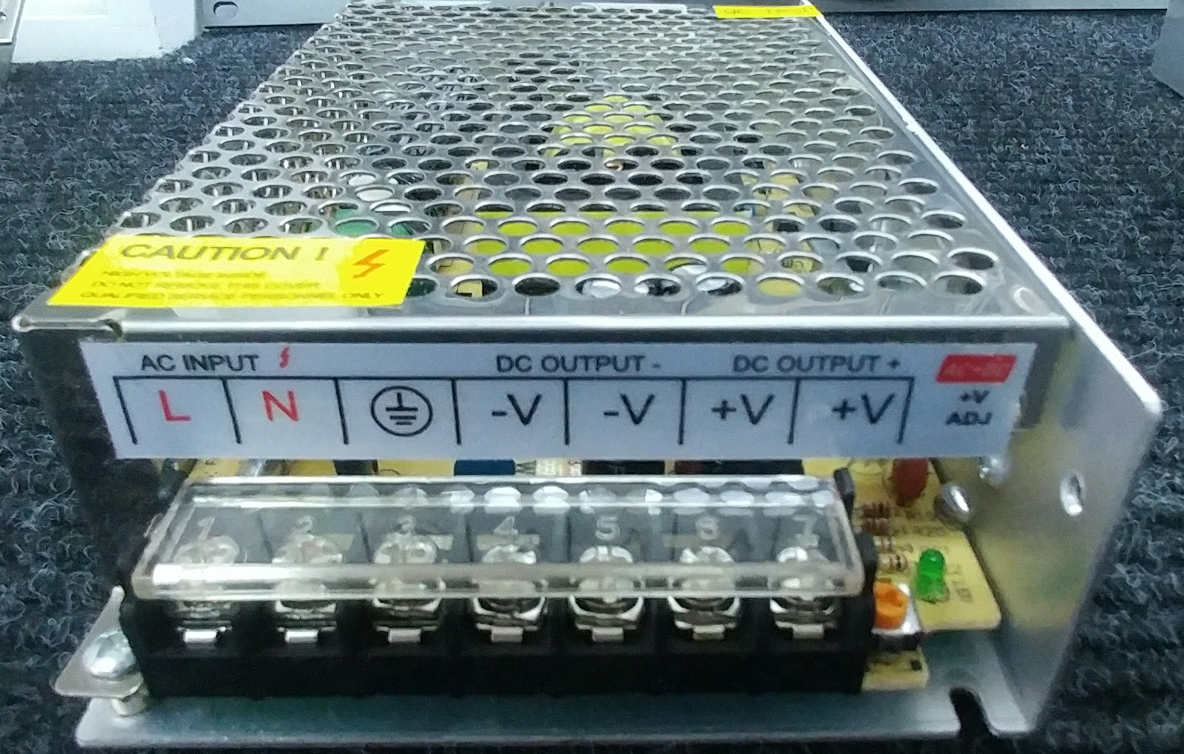 Note the voltage adjustment at the right & power LED
AC INPUT HERE
20 amp supply uses both ends, AC side and DC side with the voltage adjust hidden under the cover
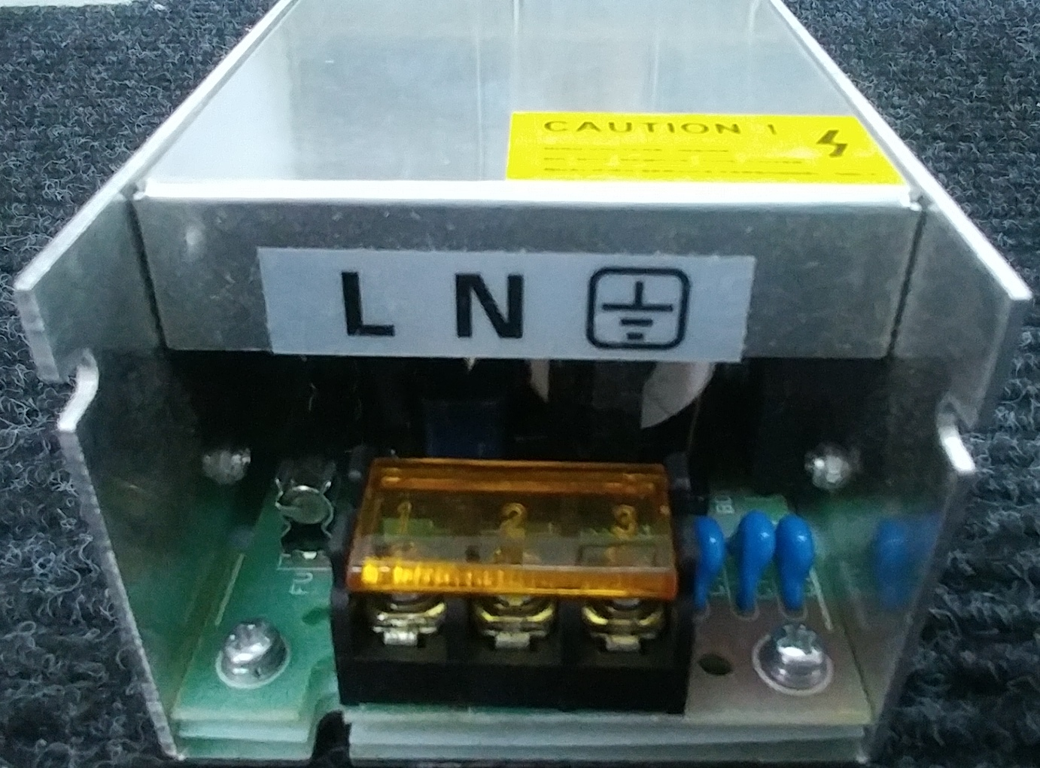 20 amp is 120 volts ONLY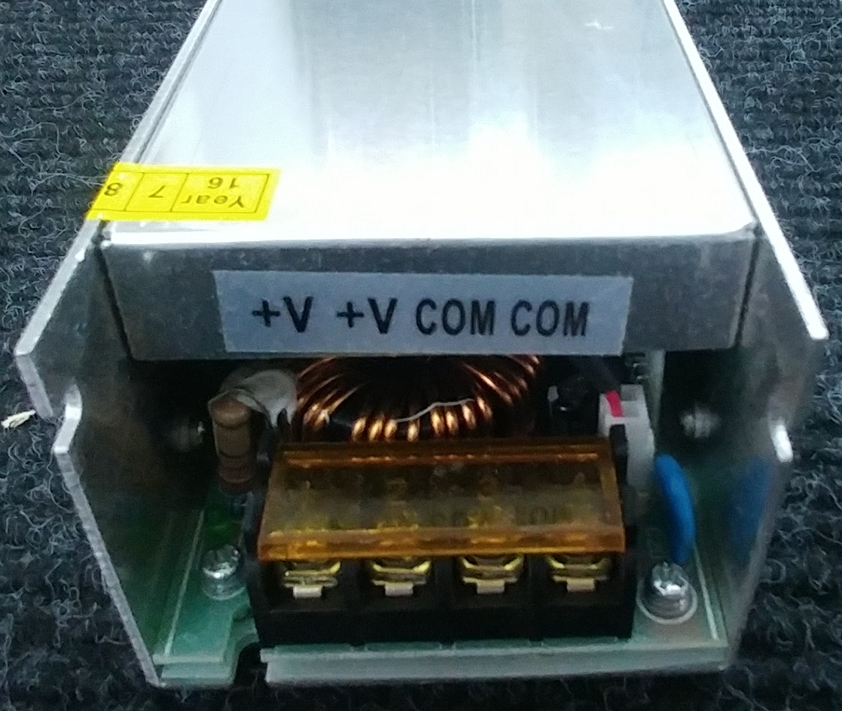

The 30 amp supply has a 110-220 volts switch on one side, insure it is set to your voltage as needed
2 or 4 size 4 mm bolts mount the 30 amp supply at least 6 ways on the Novexcomm tray.
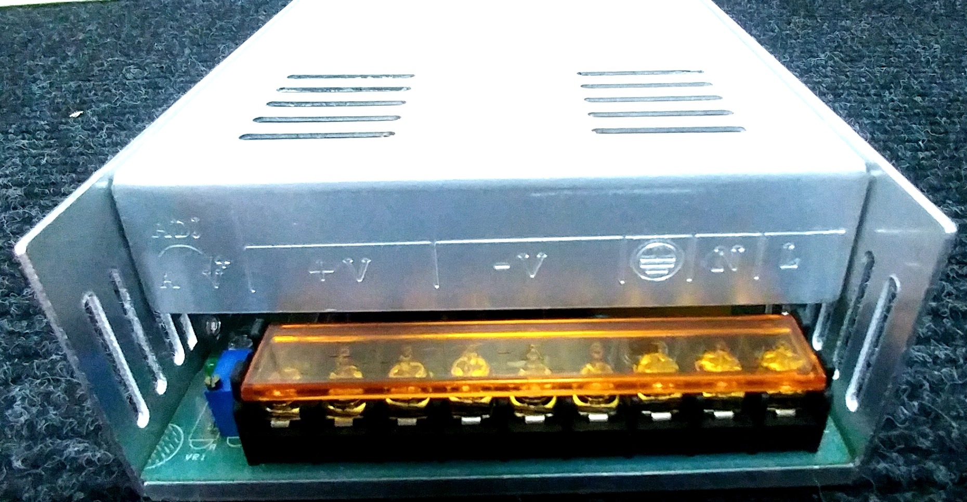 Green:(Ground),White (Neutral), Black: (Line)
AC INPUT HERE

